Epsom & Ewell F.C.
26
v
Farnham Town
Saturday, 25th March 2017 – 3.00 p.m.
Good afternoon! We welcome the players, supporters and officials of Farnham Town Football Club, today’s officials and our own regular faces for today’s League match.

I would also like to welcome G4 Contracts Limited who are our new kit sponsors. The new kit was on show last Saturday, so it is about time we recognised their donation! You will also note the new advert on the back cover of the programme (I hope!) There is also a link to their company on our own website, so by all means go and have a look! We hope to have taken some team and player photos by the time you read this and these will be available shortly.

Farnham Town have had a mixed season. Having won the League Cup in 2015/16 after defeating Camberley Town in the Final they look unlikely to secure a top half position but at the same time appear to have no relegation concerns. We won 2-1 on our last visit to the Memorial Ground which was a fairly comfortable passage until a late goal for the home side put us under a bit of pressure. Fortunately we held on and have the chance of a second League double this afternoon.

On Tuesday we hosted Windsor in the Semi-Final of the League Cup and as you will all know by now, we defeated them 2-0. It was quite a close match decided by two brilliantly created goals in our favour and scored by Matt Ferdinando and Jordan Gallagher just before the half.

In the Final we will face Westfield, who defeated Raynes Park Vale 4-0, on Friday evening 5th May at Windsor Football Club. We have met each other twice this season with the home team coming out on top on each occasion by the score of 2-1. It should be a cracker!

But back to today’s match. We are still aiming for a top four finish and there is an update on the remaining fixtures in today’s issue. It looks as though most of the teams around us will nod drop many points, so we will need to win almost all of our fixtures if we are to claim one of those slots. That makes today’s game a must win encounter, but I’m sure our boys will be up for the challenge!

We visit our old friends Camberley Town next Saturday and a week later we visit Knaphill before returning here to host Colliers Wood United on Good Friday in a match that will take place at 1.00pm.

Enjoy the game!

Rich

You can follow us on Facebook: www.facebook.com/epsomandewellfc
Twitter: @EEFCOfficial Instagram at: www.instagram.com/epsomandewellfc
and on Youtube at: www.youtube.com/channel/UCtLrpS0x5OaYUACRT34_zng

Today’s Cover Photos by Gemma Jarman

- Bentley Graham scores our winner at Farnham Town last season

- Our League Cup winning Management Team from 2013. Can we do it again?

Cherry Red Records Combined Counties League
Premier Division Table 2016/17
inc Tuesday 21st March | P | W | D | L | F | A | Pts | GD | H | A
Hartley Wintney | 36 | 30 | 4 | 2 | 122 | 35 | 97 | +87 | 0-1 | 1-3
Westfield | 36 | 22 | 8 | 6 | 81 | 42 | 74 | +39 | 2-1 | 1-2
Hanworth Villa | 38 | 22 | 8 | 8 | 68 | 39 | 74 | +29 | 2-2 | 0-1
Walton & Hersham | 38 | 20 | 13 | 5 | 66 | 37 | 73 | +29 | 1-1 | 1-1
Epsom & Ewell | 38 | 20 | 9 | 9 | 81 | 48 | 69 | +33 | X | X
Camberley Town | 36 | 17 | 6 | 13 | 71 | 52 | 57 | +19 | 0-0 | 1/4
Horley Town | 38 | 17 | 6 | 15 | 78 | 63 | 57 | +15 | 3-0 | 17/4
Abbey Rangers | 39 | 15 | 11 | 13 | 64 | 65 | 56 | -1 | 7-1 | 1-0
Knaphill | 36 | 16 | 4 | 16 | 67 | 69 | 52 | -2 | 4-0 | 8/4
Spelthorne Sports | 38 | 14 | 9 | 15 | 68 | 67 | 51 | +1 | 3-2 | 2-2
Bedfont Sports | 34 | 14 | 7 | 13 | 59 | 64 | 49 | -5 | 5-1 | 3-1
Windsor | 36 | 13 | 9 | 14 | 65 | 59 | 48 | +6 | 2-0 | 1-2
North Greenford United | 34 | 14 | 6 | 14 | 67 | 63 | 48 | +4 | 22/4 | 1-2
Sutton Common Rovers | 35 | 14 | 4 | 17 | 49 | 53 | 46 | -4 | 2-1 | 1-1
Guildford City | 38 | 13 | 6 | 19 | 70 | 78 | 45 | -8 | 1-0 | 2-0
Farnham Town | 38 | 13 | 6 | 19 | 56 | 74 | 45 | -18 | 25/3 | 2-1
AFC Hayes | 38 | 11 | 9 | 18 | 58 | 72 | 42 | -14 | 2-2 | 0-1
Chertsey Town | 37 | 12 | 6 | 19 | 51 | 85 | 42 | -34 | 2-1 | 3-0
CB Hounslow United | 36 | 12 | 4 | 20 | 50 | 71 | 40 | -21 | 1-5 | 2-0
Colliers Wood United | 36 | 10 | 9 | 17 | 56 | 68 | 39 | -12 | 14/4 | 0-5
Badshot Lea | 38 | 10 | 4 | 24 | 56 | 101 | 34 | -45 | 4-2 | 4-1
Bedfont & Feltham | 37 | 7 | 6 | 24 | 47 | 107 | 27 | -60 | 4-1 | 9-2
Raynes Park Vale | 37 | 6 | 8 | 23 | 40 | 78 | 26 | -38 | 1-1 | 1-1

Lucky Day? – 25th March
Played 13 - Won 6 Drawn 1 Lost 6 - For 17 Against 26 - PPG 1.46 - Average
Our Club record against today’s opponent
Played 14 - Won 8 Drawn 2 Lost 4 - For 25 Against 23 - PPG 1.86 - Good
Our Largest wins and losses against today’s opponent
1st December 2012 - W 3-1 - Combined Counties League (H)
20th March 2012 - L 1-4 - Combined Counties League (H)
Their Last Visit
26th September 2015 - Won 1-0 - Combined Counties League

First Eleven Appearances 2016/17 - (max 49)
Name | Debut | 2016/17 |  |  |  | Career Totals
 |  | App | Sub | Total | Goals | App | Sub | Total | Goals
CLARK-GLEAVE Charlie* | 23/08/2016 | 3 | 2 | 5 | 0 | 3 | 2 | 5 | 0
COOPER-SMITH Daryl | 03/01/2015 | 31 | 5 | 36 | 31 | 61 | 13 | 74 | 51
DEAN Dan | 02/08/2014 | 36 | 2 | 38 | 2 | 104 | 6 | 110 | 4
DEWAR Ali | 29/10/2011 | 0 | 5 | 5 | 0 | 55 | 40 | 95 | 10
EACOTT Michael | 02/08/2014 | 41 | 0 | 41 | 0 | 126 | 1 | 127 | 0
FARRELL Matt | 02/08/2014 | 45 | 0 | 45 | 16 | 131 | 4 | 135 | 34
FERDINANDO Matt | 20/09/2014 | 28 | 8 | 36 | 10 | 81 | 14 | 95 | 24
GALLAGHER Jordan | 07/08/2016 | 35 | 12 | 47 | 12 | 35 | 12 | 47 | 12
GRIFFIN Reisse | 08/08/2015 | 38 | 7 | 45 | 2 | 66 | 13 | 79 | 4
HASTINGS Craig | 08/08/2015 | 30 | 7 | 37 | 2 | 67 | 11 | 78 | 2
HEAGNEY Adam | 16/08/2016 | 33 | 7 | 40 | 0 | 33 | 7 | 40 | 0
HENDRY Rob | 08/08/2015 | 34 | 9 | 43 | 10 | 64 | 20 | 84 | 22
MCKAY Alex | 20/12/2008 | 18 | 6 | 24 | 3 | 126 | 36 | 162 | 11
NEALE Tom* | 13/10/2015 | 6 | 5 | 11 | 7 | 22 | 24 | 46 | 17
NORTH Rhys | 16/08/2015 | 3 | 3 | 6 | 0 | 20 | 10 | 30 | 1
NWACHUKWU Jason | 01/10/2016 | 13 | 13 | 26 | 1 | 13 | 13 | 26 | 1
PANAYIOTOU Savvas | 03/01/2015 | 41 | 4 | 45 | 5 | 73 | 12 | 85 | 12
PRICE Matt* | 23/08/2016 | 2 | 0 | 2 | 1 | 2 | 0 | 2 | 1
ROBINSON Sam* | 22/10/2011 | 7 | 1 | 8 | 1 | 61 | 6 | 67 | 14
ROSE Daniel | 25/10/2016 | 2 | 5 | 7 | 0 | 2 | 5 | 7 | 0
SALEH Mennar* | 24/09/2016 | 0 | 2 | 2 | 0 | 0 | 2 | 2 | 0
SMITH Matt | 08/08/2009 | 0 | 3 | 3 | 1 | 91 | 46 | 137 | 11
TANTON Matt | 02/08/2014 | 40 | 2 | 42 | 1 | 97 | 6 | 103 | 3
TAYLOR James | 26/08/2013 | 41 | 3 | 44 | 2 | 127 | 15 | 142 | 8
THOMPSON Elliott | 09/02/2016 | 3 | 0 | 3 | 1 | 7 | 9 | 16 | 1
TURPIE Alistair | 31/03/2016 | 8 | 1 | 9 | 0 | 10 | 1 | 11 | 0
WATRET Jack* | 02/08/2016 | 1 | 0 | 1 | 0 | 1 | 0 | 1 | 0
Own goals |  |  |  |  | 1
* player has left the club

Latest Results and Fixtures
Combined Counties League – Saturday 18th March
Bedfont & Feltham | 3-2 | Colliers Wood United
Camberley Town | 1-3 | AFC Hayes
Chertsey Town | 2-1 | Raynes Park Vale
Epsom & Ewell | 0-1 | Hartley Wintney
Farnham Town | 2-1 | Knaphill
Hanworth Villa | 4-0 | Badshot Lea
Horley Town | 2-0 | CB Hounslow United
North Greenford United | 2-1 | Guildford City
Spelthorne Sports | 1-1 | Abbey Rangers
Sutton Common Rovers | 0-1 | Walton & Hersham
Westfield | 2-1 | Windsor
Combined Counties League – Monday 20th March
Abbey Rangers | 2-2 | North Greenford United
Sutton Common Rovers | 0-1 | Bedfont & Feltham
Combined Counties League Cup Semi-Finals – Tuesday 21st March
Epsom & Ewell | 2-0 | Windsor
Raynes Park Vale | 0-4 | Westfield
Combined Counties League – Tuesday 21st March
Badshot Lea | 3-1 | Chertsey Town
Knaphill | 2-0 | Horley Town
Combined Counties League – Saturday 25th March
Badshot Lea | V | Sutton Common Rovers
CB Hounslow United | V | Abbey Rangers
Chertsey Town | V | Colliers Wood United
Epsom & Ewell | V | Farnham Town
Guildford City | V | Walton & Hersham
Hartley Wintney | V | Horley Town
Knaphill | V | North Greenford United
Raynes Park Vale | V | Camberley Town
Westfield | V | Bedfont & Feltham
Windsor | V | AFC Hayes
Combined Counties League – Monday 27th March
Sutton Common Rovers | V | Windsor
Combined Counties League – Tuesday 28th March
Bedfont Sports | V | Camberley Town
Knaphill | V | Bedfont & Feltham
Latest Results and Fixtures
Combined Counties League – Tuesday 28th March
North Greenford United | V | Colliers Wood United
Raynes Park Vale | V | CB Hounslow United
Walton & Hersham | V | Hanworth Villa
Combined Counties League – Saturday 1st April
Abbey Rangers | V | Westfield
AFC Hayes | V | Raynes Park Vale
Bedfont & Feltham | V | Spelthorne Sports
Camberley Town | V | Epsom & Ewell
Chertsey Town | V | Hartley Wintney
Colliers Wood United | V | Knaphill
Farnham Town | V | CB Hounslow United
Hanworth Villa | V | Windsor
Horley Town | V | Badshot Lea
North Greenford United | V | Bedfont Sports
Sutton Common Rovers | V | Guildford City
Combined Counties League – Tuesday 4th April
Bedfont Sports | V | CB Hounslow United
Chertsey Town | V | Sutton Common Rovers
Hartley Wintney | V | Windsor
North Greenford United | V | Camberley Town
Combined Counties League – Saturday 8th April
Abbey Rangers | V | Colliers Wood United
Badshot Lea | V | Windsor
CB Hounslow United | V | Bedfont & Feltham
Farnham Town | V | Horley Town
Guildford City | V | Hartley Wintney
Hanworth Villa | V | Bedfont Sports
Knaphill | V | Epsom & Ewell
Raynes Park Vale | V | North Greenford United
Spelthorne Sports | V | Chertsey Town
Walton & Hersham | V | Camberley Town
Westfield | V | Sutton Common Rovers
Combined Counties League – Tuesday 11th April
Bedfont Sports | V | Westfield
Knaphill | V | Colliers Wood United
Combined Counties League – Friday 14th April
Epsom & Ewell | 1pm | Colliers Wood United

From behind the goal
Epsom & Ewell 2-0 Windsor
Combined Counties League Cup - Semi-Final - Tuesday 21st March 2017

Salts edge Stags to reach Cup Final

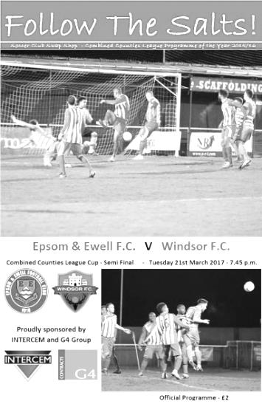
Our biggest home attendance of the season, 130, gathered at High Road for an important League Cup Semi-Final. The contest was a compelling encounter, even if it was a bit scrappy and low on quality at times. In the end the difference between the two teams was that little bit of quality in front of goal and when the final whistle blew we had replicated our 2-0 League win from November.

We made a couple of changes following our narrow defeat to Hartley Wintney as Craig Hastings came in at the back, moving James Taylor over to right back with Adam Heagney dropping to the bench and up front Daryl Cooper-Smith returned from suspension to lead the line so Rob Hendry moved out to the right wing at the expense of Reisse Griffin.

We started slightly the brighter of the two teams and got better as the half went on. We earned an early free kick in the third minute but Matt Ferdinando struck the set piece into the wall. Shortly after this Cooper-Smith set up Agi Panayiotou for a shot from the edge of the area only to find that effort blocked for a corner from which visiting keeper Hugo Sobte was alert to palm the deep delivery from Ferdinando away before it crept in at the back post.

We nearly broke through in the 24th minute from another corner, this time from Panayiotou and Cooper-Smith lost his man and targeted a header back at goal that came back off the underside of the Windsor crossbar. We then should have had a goal in the 31st minute when a left wing cross from Matt Farrell was flicked on to Rob Hendry at the back and his shot was drilled back across goal and into the net off a covering defender but he was adjudged offside. There appeared no doubt he was in an offside position but the ball had actually been flicked on by a defender just ahead of Taylor who was in the vicinity.

We were getting on top now. Ferdinando then set up Panayiotou after beating a couple of men but he also found his shot blocked. The Windsor defenders were doing a good job and on a rare break they had a big shout for handball when a right wing cross hit one of our defenders. However, the large appeal came mainly from the supporters gathered behind Michael Eacott's goal and neither the referee nor the Assistant were interested in it.

Within a minute, the 39th, if you like that sort of thing, we were ahead and this was all

down to persistence from Cooper-Smith. He chased a long goal kick despite being second favourite to get to the ball. However, he half blocked the defender's clearance and as the loose ball spun towards goal he reached it first, running in from the touchline, drawing the keeper and then laying the ball back for Ferdinando to drill the ball home off a defender from eight yards out.

One goal became two in the 42nd minute when Hendry was sent down the right and he sent a peach of a cross just beyond the far post where Jordan Gallagher was waiting to nod in from close range. We walked off at half time with a huge advantage.

The second half started fairly well with Hendry sending a powerful strike at goal from 20 yards although Sobte made a routine save. However, we dodged a bullet in the 52nd minute when a ball towards our defence was flicked on and Rob Lazarczuk was through on goal. Fortunately for us from just inside the penalty area he dragged his shot horribly wide.

I thought we had been fortunate there and would then close the door on the visitors, but the game changed at that point and we appeared to lose our way. We would struggle to gain much possession for the remainder of the second half as a result. We still created sporadic chances like in the 66th minute when Hendry retrieved the ball after Sobte tried a left footed clearance and sliced it wide. Hendry won a corner from this, from which Taylor was just over the bar with his near post volley.

In the 73rd minute Hendry nearly made it 3-0 with a long range curling effort but Sobte got a hand on the ball at full stretch to turn it round the far post for a corner. Then Cooper-Smith's shot took a kind deflection to Panayiotou but he also found his shot parried away by Sobte.

We were seeing little of the ball as the match entered its final stages but still looked as likely to score on the counter attack as our opponents. Farrell was wide with a speculative 45 yard effort after Ferdinando had half blocked a Sobte clearance and although we picked up three bookings on the night, one of which will lead to a suspension, we were looking more and more like we would hold on. As we neared the end a free kick in a dangerous position was struck into our wall and then in injury time, a long range effort was flicked on to our crossbar as the visitors pushed for a consolation but it was clearly destined to be our night.

Although some Windsor fans might argue they were worth a draw based on their second half ascendency it has to be said that possession only gets you so far, and in the end Eacott had more to deal with in terms of banter from the visiting fans behind the goal than he did from the Windsor strikers! We now look forward to a Cup Final against Westfield at the end of the season on a date and at a venue to be advised shortly.

Epsom and Ewell: Michael Eacott, James Taylor, Matt Tanton, Craig Hastings, Dan Dean (c), Savvas 'Agi' Panayiotou, Jordan Gallagher, Matt Farrell,
Daryl Cooper-Smith, Matt Ferdinando, Rob Hendry

Subs: Reisse Griffin for Gallagher (89), Jason Nwachukwu for Ferdinando (91)

Club Records - 25th March
Date | Day | Competition |  | Opponents |  | Scorers
25/03/32 | Fri | London League | A | Tooting Town | 5-1 | B.Williams (4), L.Graves
25/03/33 | Sat | London League | A | Cray Wanderers | 1-4 | R.Marlow
25/03/39 | Sat | London League | H | P.O.Engineers | 3-2 | T.Rochester, B.Solly, A.Curtis
25/03/50 | Sat | Corinthian League | A | Walton & Hersham | 0-5
25/03/61 | Sat | Corinthian League | H | Wembley | 1-1 | G.King
25/03/72 | Sat | Athenian League 2 | H | Ruislip Manor | 0-3
25/03/78 | Sat | Isthmian League 2 | H | Egham Town | 1-0 | J.Hunn (pen)
25/03/89 | Sat | Isthmian League 2s | H | Ruislip Manor | 0-1
25/03/93 | Thur | Southern Combination Cup 2 | H | Walton & Hersham | 3-2+ | P.Meredith, T.Tweedy, A.Nimmo
25/03/95 | Sat | Isthmian League 3 | A | Leighton Town | 1-0 | K.Webb
25/03/00 | Sat | Isthmian League 3 | H | Camberley Town | 2-1 | B.Forey, D.Marvell
25/03/06 | Sat | Isthmian League 2 | H | Chalfont St Peter | 0-4
25/03/16 | Fri | Combined Counties  Premier Division | H | Westfield | 0-2
Historical Decades
Date | Day | Competition |  | Opponents |  | Scorers
90 years ago – Epsom Town F.C.
26/03/27 | Sat | Surrey Senior League | A | Addlestone | 5-0 | R.Marlow (2), E.Olley, J.Parr, R.Sperring
80 years ago – Epsom F.C.
26/03/37 | Fri | London League | A | Tooting & Mitcham United | 2-0 | B.Beglan, T.Dunne
70 years ago – Epsom F.C.
29/03/47 | Sat | London League | H | Woodford Town | 4-2 | D.Ralph (2), F.Taylor, F.Chitty
60 years ago – Epsom F.C.
23/03/57 | Sat | Corinthian League | A | Tilbury | 1-0 | B.Jenkins
50 years ago – Epsom & Ewell F.C.
24/03/67 | Fri | Athenian League 2 | H | Marlow | 0-0
40 years ago – Epsom & Ewell F.C.
26/03/77 | Sat | Athenian League 1 | A | Cheshunt | 0-1
30 years ago – Epsom & Ewell F.C.
28/03/87 | Sat | Isthmian League 1 | H | Hampton | 1-0 | T.Tuite
20 years ago – Epsom & Ewell F.C.
29/03/97 | Sat | Isthmian League 3 | A | Flackwell Heath | 1-2 | A.Boxall
10 years ago – Epsom & Ewell F.C.
24/03/07 | Sat | Combined Counties  Premier Division | A | Wembley | 0-5

History Corner – 25th March
90 years ago this week we handed Addlestone a lesson with a 5-0 thrashing at their old ground in Alexandra Road. This was par for the course really as this was our sixth meeting since both clubs had joined the Surrey Senior League and although we drew the first of these, the next five all produced comfortable wins for Epsom Town. Reg Marlow scored another brace to take him to a club record 58 for the season, and would eventually reach 65 while Ernest Olley, Jack Parr and Reg Sperring also found the net.

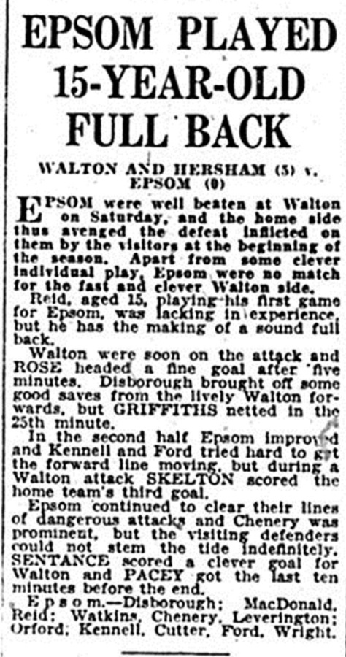
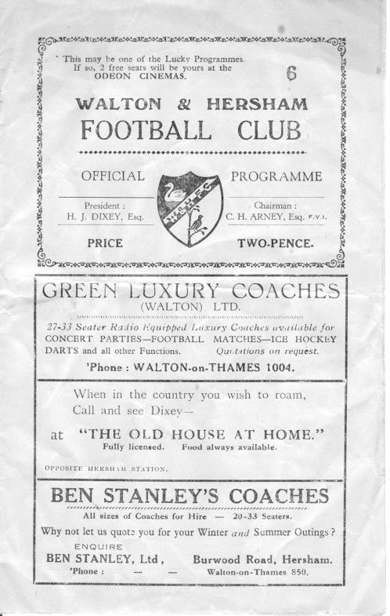
85 years ago today we won 5-1 at Sandy Lane against Tooting Town in a London League match. Billy Williams the former West Ham Professional player scored another four goals for us, to bring his tally to 26 in just 15 appearances, finishing with 41 from 26 by the season’s end! Three days later on the Easter Monday we defeated them 5-2 for our last ever meeting with the club before it merged with Mitcham Wanderers in the summer of 1932 to form the Tooting & Mitcham we know today.

67 years ago today we were defeated heavily at Walton & Hersham in a Corinthian League match. We were badly short of players though and fielded a 15 year old member of the Fulham Ground staff by the name of F.Reid at full back. By all accounts though he did ok although I cannot trace him ever graduating to the Fulham first team. This was the only match he would play for us. (see report and programme above)

24 years ago today and also against Walton & Hersham, we defeated them 3-2 after extra time in the Southern Combination Cup. This enabled a home semi-final to take place against Chipstead which would become the last ever first team match at West Street.

Every Opponent A-Z
Over the years we have played many, many different opponents. Exactly how many is a difficult question, as it all depends on your definition. Are Camberley & Yorktown different to Camberley Town, or are Epsom Town different to Epsom F.C. or Epsom & Ewell F.C.?

In my analysis I have classed both of the above examples as the same team, and will work through them all from A to Z. Some we have played many times, whilst others we have met just once or twice. Enjoy!

Walthamstow Avenue: Played 6 - W1 D3 L2 - F9 A17 - PPG - 1.00 - Poor

Walthamstow Avenue were a very powerful Amateur team that came to prominence just after the Second World War. They were actually elected to the Isthmian League in 1939 after a few years as Athenian League members but the war ensured just one match would be played and they had to wait a further six years before being able to properly commence Isthmian matches but they promptly won the League in that first season.

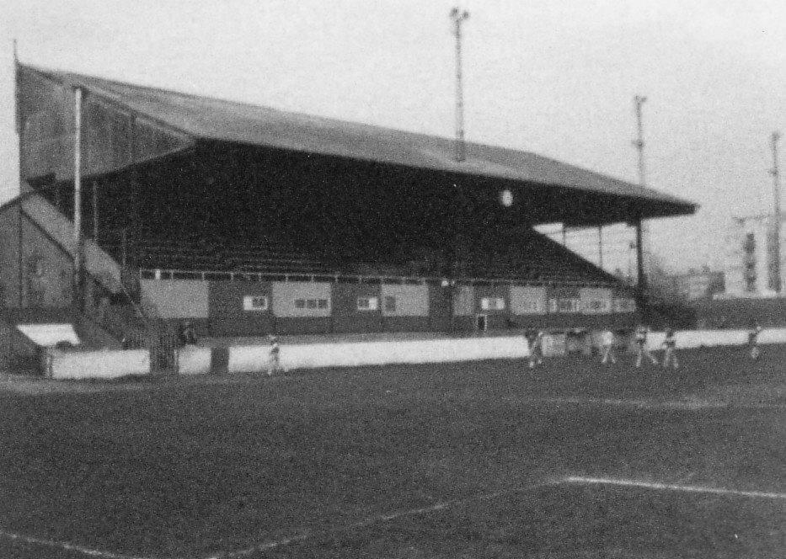
One of the iconic non-league stands of the Twentieth Century at Green Pond Road
built back in the thirties. Now that’s what I call a stand!

Under the stewardship of one of the greatest Amateur father and son pairings Jim Lewis and Jim

Lewis Junior, the club became Amateur Cup winners in front of 100,000 at Wembley in 1952 and then the following season reached the Fourth Round of the F.A. Cup, holding Manchester United to a 1-1 draw before departing the competition in a replay. Lewis Junior was also heavily involved with the Chelsea team that won the Football League for the very first time in 1954/55, a feat they would not repeat until 2004/05.

The club won the Amateur Cup once again in 1961 and we were paired together in the F.A. Cup in 1963/64 with disastrous consequences. We were a struggling club at the foot of the newly formed Athenian League Division One at that stage and lost 8-0 at West Street in front of 600 spectators.

The other five meetings came whilst we were having a two year spell in the Isthmian League Premier Division, drawing three of the four matches but then losing 1-2 at West Street in January 1986 as we fought a losing battle against relegation. We also met at Green Pond Road in the London Senior Cup in February 1985 where a Tommy Tuite hat trick ensured a 3-2 win with all five goals coming in the second half.

In 1986 we were relegated and would never meet again, but for them a period of massive turbulence was on his way. It started up the road with the merger of Leytonstone and Ilford following the latter’s loss of the Lynn Road ground.

This was then followed in 1986/87 by the loss of Leytonstone’s Granleigh Road. This led to the newly merged club sharing at Green Pond Road and within a year Walthamstow had merged with them into a newly formed Redbridge Forest. The Green Pond Road ground was sold and they moved into Victoria Road with Dagenham, merging shortly afterwards into the Dagenham and Redbridge we know today. So they sort of still exist. Technically!

Walthamstow Grange: Played 9 - W5 D2 L1 Aban 1 - F27 A17 - PPG - 2.13 - Very Good

Much less is known about Walthamstow Grange, who were the senior club in the town before World War One. Playing at what would become the Walthamstow Greyhound Stadium in Chingford Road they joined the London League and remained in it until 1931 when the club folded, quite possibly as a result of the site was bought and converted into the Stadium that was still active less than ten years ago.

We played nine matches during our first four seasons in the London League and our first meeting occurred on 11th February 1928 in Walthamstow when goals from Fred Behn and Fred Watts secured a 2-1 win. We won the return fixture 4-0 at West Street on 9th April 1928 on our way to the London League title. We then completed a second League double the following season with a 6-0 home win with three different players all scoring twice, and then a narrow 3-2 win there at the end of March 1929.

In drawing 1-1 on 9th November 1929 there were two notable incidents. Firstly, it was Walthamstow Grange’s first point against us but it was also the fifth match in a row between the teams that Fred Behn had scored in!

We had some serious fortune in the return leg on 11th January 1930 as we trailed 4-0 after 40 minutes only to escape when the match was abandoned for fog and when we returned to play the match on a Thursday night in May a goal from E.Matkin enabled us to draw 1-1.

The final season of meetings was in 1930/31 and took place over the Easter weekend with a trip to the Walthamstow ground on 3rd April where we were battered 5-3, yet three days later Herbert Pattemore the Welsh International scored four times as we gained revenge with a 7-3 home win.

With no ground and the Avenue on the doorstep playing at a higher level by now (and winning the Athenian League five times in the Thirties, there was no appetite for the Grange to continue and the club folded in 1931.

Cherry Red Records Combined Counties League
Premier Division FORM Table – Last 10 Matches
Here is the current state of play based on every club’s last ten League matches. If we keep doing well, the table stays in the programme! Interesting to note that the top five in the League are the top five in this table! Also note the resurgent Badshot Lea who I believe will escape relegation, leaving AFC Hayes and Colliers Wood in a lot of danger!

inc Tuesday 21st March | P | W | D | L | F | A | Pts | GD
Hartley Wintney | 10 | 9 | 1 | 0 | 35 | 9 | 28 | +26
Epsom & Ewell | 10 | 7 | 2 | 1 | 22 | 9 | 23 | +13
Walton & Hersham | 10 | 7 | 2 | 1 | 20 | 8 | 23 | +12
Hanworth Villa | 10 | 6 | 3 | 1 | 18 | 8 | 21 | +10
Westfield | 10 | 6 | 2 | 2 | 23 | 13 | 20 | +10
Spelthorne Sports | 10 | 4 | 4 | 2 | 20 | 13 | 16 | +7
Badshot Lea | 10 | 5 | 1 | 4 | 22 | 23 | 16 | -1
Sutton Common Rovers | 10 | 5 | 0 | 5 | 13 | 9 | 15 | +4
Abbey Rangers | 10 | 3 | 6 | 1 | 15 | 12 | 15 | +3
Chertsey Town | 10 | 5 | 0 | 5 | 15 | 21 | 15 | -6
North Greenford United | 10 | 4 | 2 | 4 | 16 | 17 | 14 | -1
Farnham Town | 10 | 4 | 2 | 4 | 16 | 17 | 14 | -1
Camberley Town | 10 | 4 | 2 | 4 | 17 | 21 | 14 | -4
Windsor | 10 | 3 | 4 | 3 | 17 | 11 | 13 | +6
Bedfont Sports | 10 | 3 | 2 | 5 | 16 | 19 | 11 | -3
CB Hounslow United | 10 | 3 | 1 | 6 | 9 | 15 | 10 | -6
Knaphill | 10 | 3 | 1 | 6 | 14 | 20 | 10 | -6
Bedfont & Feltham | 10 | 3 | 1 | 6 | 15 | 28 | 10 | -13
AFC Hayes | 10 | 2 | 3 | 5 | 12 | 18 | 9 | -6
Horley Town | 10 | 2 | 1 | 7 | 14 | 19 | 7 | -5
Guildford City | 10 | 2 | 1 | 7 | 12 | 19 | 7 | -7
Raynes Park Vale | 10 | 2 | 1 | 7 | 7 | 19 | 7 | -12
Colliers Wood United | 10 | 1 | 1 | 8 | 13 | 25 | 4 | -12

EL Records Premier Challenge Cup
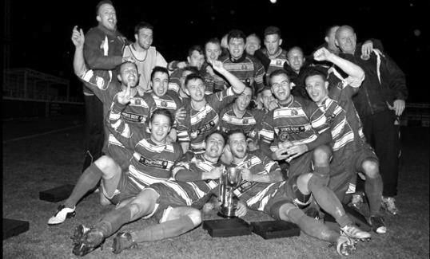
Second Round
Hanworth Villa | 2-4+ | Epsom and Ewell
AFC Hayes | 3-4 | Balham
Epsom Athletic | 1-5 | Windsor
Sutton Common Rovers | 2-1 | Bedfont Sports
Raynes Park Vale | 2-0 | Colliers Wood United
Frimley Green | 1-2 | Banstead Athletic
Westfield | 8-4+ | Redhill
Staines Lammas | 0-1 | Farnham Town
Worcester Park | 8-1 | Cove
Badshot Lea | 0-5 | Guildford City
Chertsey Town | 1-2 | Camberley Town
Cobham | 1-3 | Chessington & Hook United
Hartley Wintney | 4-0 | AC London
Horley Town | 2-2+ 5-4p | Sheerwater
Walton & Hersham | 5-1 | Eversley & California
Ash United | 2-0 | Farleigh Rovers
Third Round
Banstead Athletic | 4-4+ 3-4p | Westfield
Sutton Common Rovers | 1-3 | Walton & Hersham
Farnham Town | 0-4 | Camberley Town
Ash United | 0-2 | Windsor
Raynes Park Vale | 2-1 | Hartley Wintney
Guildford City | 2-1 | Balham
Horley Town | 2-0 | Chessington & Hook United
Worcester Park | 3-6 | Epsom & Ewell
Quarter Finals
Windsor | 2-0 | Horley Town
Guildford City | 1-2 | Raynes Park Vale
Westfield | 4-1 | Camberley Town
Walton & Hersham | 1-3 | Epsom & Ewell
Semi Finals
Epsom & Ewell | 2-0 | Windsor
Raynes Park Vale | 0-4 | Westfield
Final @ Windsor F.C. – Friday 5th May – 7.45pm k.o.
Epsom & Ewell | V | Westfield

Centre page for results

Centre page for results

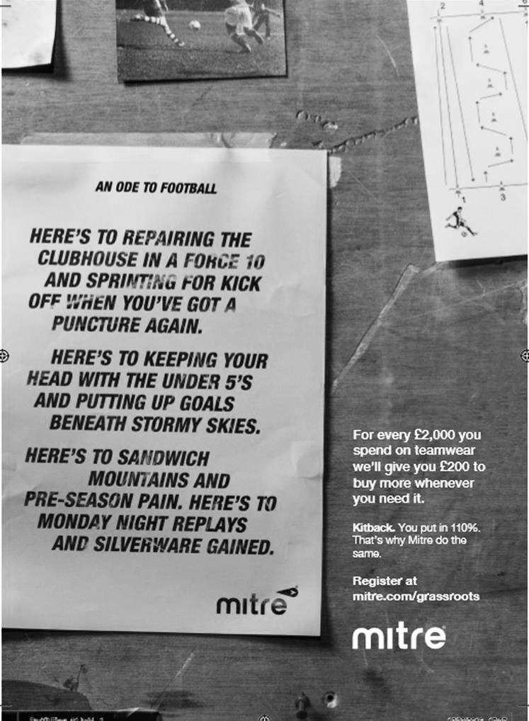

Farnham Town – History
Established in 1906 through the merging of Farnham Bungs (the Farnham Brewery) and the Farnham Star. The club was one of the founder members of the London Spartan League in 1975. They reached the Fourth Round of the FA Vase in the 1976-77 season.

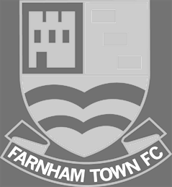
At the end of the 1979/80 season Farnham Town left the London Spartan League and applied to the Combined Counties League, their application was accepted and they finished 4th in their first season. The 1986/87 season saw Farnham take second place to Ash United in the league campaign. The glory days finally arrived in the 1990/91 season when the club won the league title. In the 1991/92 season, the Town got a clean sweep of the major trophies by winning the Combined Counties Premier League, the Dan Air Elite Cup and the Dan Air Challenge Cup. Having won the league, the club applied and were accepted to the Diadora League, however funds for necessary ground improvements could not be generated which resulted in the club not having a league to play in for the 1992/93 season.

In 1993/94 Farnham Town were accepted back into the Combined Counties League where they continue to ply their trade. From 1995-1998 Farnham finished in the top six of the Premier Division for three consecutive seasons, in 1998-99 they finished in 13th position, then 10th in 1999-2000 before suffering relegation from the Premier Division in 2000-2001 season. They bounced straight back the following season but then endured four tough seasons back in the Premier Division, with bottom four finishes every season culminating in relegation back down to Division One in 2005-2006. Again, the club bounced straight back and in 2006-2007 they won the Division One title under the guidance of Barry Bridger, but were denied promotion due to the Memorial Ground not meeting the desired grading by the league. The club then spent another four seasons in Combined Counties Division One.

Farnham gained promotion from Combined Counties Division One in the 2010-2011season after finishing second behind Worcester Park. In Paul Tanner’s first season at the helm he gained automatic promotion back to the Premier Division at the first attempt, which after only retaining four members of the side from the previous year’s squad - who finished midtable, was quite an achievement. Paul Tanner’s side also won the Combined Counties Fair Play Award for 2010-2011 after going the whole season without having a man sent off, a record to be proud of. In a very successful year for the club on the whole, Dean Nelson’s reserve side finished second behind Mole Valley in the Combined Counties Reserve Division, improving on fourth position the previous season. Farnham Ladies also finished second in their respective league to cap quite a remarkable season in Geoff Chapple’s final season as Chairman. In 2011, Ray Bridger took over as chairman from Geoff Chapple.

Current first team manager and now in his 8th season at the club is Paul Tanner, alongside head coach Sean Birchnall and in 2016 we won the Combined Counties League Challenge Cup defeating Camberley Town at Windsor’s Stag Meadow ground.

Match and Ball Sponsorships – 2016/17
Opponent | Date | Match Sponsor | Ball Sponsor
Gravesham Borough | 07/08/16 | Club President - Stella Lamont
Gravesham Borough | 07/08/16 | Relocation Committee Member - Mike Lovett
CB Hounslow United | 16/08/16 | EEFC Management Committee
Abbey Rangers | 23/08/16 | Steve & Geoff Dyke
Horley Town (11.30am) | 29/08/16 | In Memory of Chris Henry
Abbey Rangers (LC) | 06/09/16 | Paul Merritt
Camberley Town | 10/09/16 | Building Shop Ltd
Knaphill | 24/09/16 | EEFC Holding Company Director – Pete Lumm
Bridon Ropes (FAV) | 22/10/16 | George and Joseph Saunders
Sutton Common Rovers | 08/11/15 | Alex McKay Senior
Abbey Rangers (FAV) | 13/11/16 | EEFC Holding Company Director – Dave Ellins
Windsor | 15/11/16 | In Memory of Wally Dyke
Bedfont Sports | 19/11/16 | John Bonner
AFC Hayes | 26/11/16 | Jack Jarman
Chipstead (SSC / DWT) | 06/12/16 | Trevor Stotten
Hanworth Villa | 13/12/16 | Roger and Carol Farrell
Chertsey Town | 17/12/16
Raynes Park Vale (11.30am) | 27/12/16 | In memory of Dave and Liz Marshall
Spelthorne Sports | 07/01/17 | Building Shop Ltd
Guildford City (SSC) | 10/01/17 | Super Six Winner – Rita Christian
Guildford City | 17/01/17
Badshot Lea | 04/02/17
Westfield | 18/02/17 | Tony Coome
Walton & Hersham | 04/03/17 | Super Six Winner – Rita Christian
Bedfont & Feltham | 07/03/17 | Programme Editor - Richard Lambert
Hartley Wintney | 18/03/17
Windsor (LC SF) | 21/03/17 | In memory of Bob Bexley
Farnham Town | 25/03/17 | In memory of Jean Bexley
Colliers Wood United (1pm) | 14/04/17
North Greenford United | 22/04/17 | Club President - Stella Lamont
For League, League Cup and Surrey Senior Cup Matches:
Match sponsorship - £40.00 Match ball sponsorship - £25.00. Combined £55.00.
For F.A. Cup and F.A. Vase matches:
Match sponsorship - £50.00 Match ball sponsorship - £30.00. Combined £65.00.

Sponsorship includes: (x2 for match, x3 for match and ball)

Admission, programmes, hospitality and advertising and mascot for the day (if required).
If you are interested, just speak to a Committee Member, or drop me an email at: richard.c.lambert@gmail.com

We also thank our Sponsors INTERCEM and G4 Group

Player Sponsorship
Here is the current list for the 2016/17 season showing all of our players and Management that are available for sponsorship.

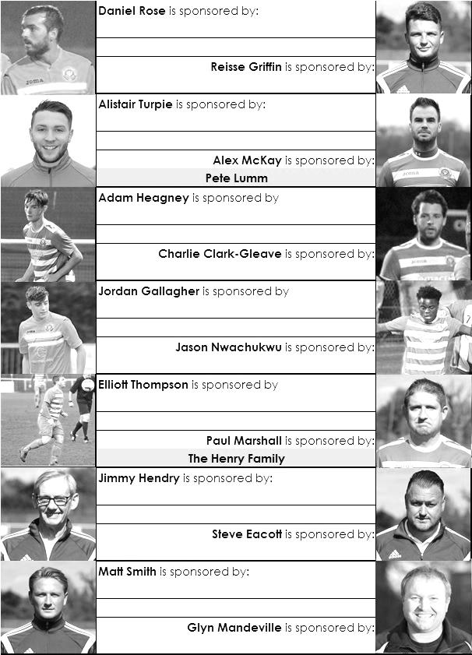

Sponsorship costs just £40 and it is easy to do. Just select a player who has not been previously sponsored and let a Committee Member know that you would like to sponsor them. Beware though. Until we have received the money it is possible for someone to jump in front of you, so don’t delay, sponsor today!
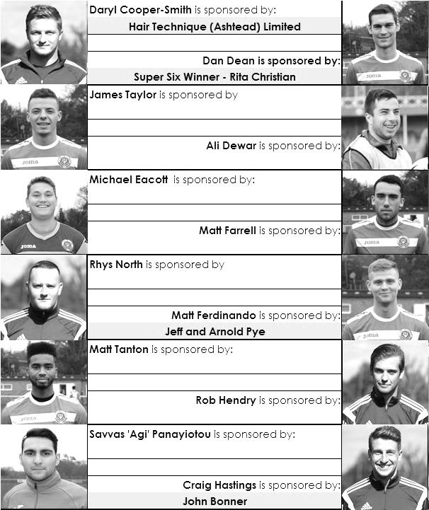

Surrey Senior Cup
Third Round
Whyteleafe | 2-0 | Egham Town
Badshot Lea | 0-2 | Raynes Park Vale
Epsom & Ewell | 1-2 | Guildford City
Dorking Wanderers | 1-1 8p7 | Sutton Common Rovers
Chertsey Town | 1-0 | Kingstonian
Woking | 2-0 | Leatherhead
Merstham | 5-1 | Walton & Hersham
Tooting & Mitcham United | 0-1 | Knaphill
Quarter Final
Guildford City | 2-1 | Raynes Park Vale
Chertsey Town | 0-3 | Dorking Wanderers
Merstham | 2-1 | Whyteleafe
Woking | 3-1 | Knaphill
Semi Final
Guildford City | 1-2 | Woking
Dorking Wanderers | 2-3 | Merstham

F.A. Vase
Fifth Round – 28th / 29th January
Cleethorpes Town | 3-2 | Atherton Collieries
Southall | 4-2 | Exmouth Town
Bromsgrove Sporting | 2-1 | Bristol Manor Farm
Crowborough Athletic | 3-6 | Coleshill Town
Hinckley AFC | 3-4+ | Buckland Athletic
Newport Pagnell Town | 3-2+ | Sunderland RCA
Ely City | 0-3 | Sporting Khalsa
Team Solent | 2-5 | South Shields
Quarter - Final – 18th February
South Shields | 6-1 | Newport Pagnell Town
Southall | 2-5 | Cleethorpes Town
Bromsgrove Sporting | 2-0 | Buckland Athletic
Coleshill Town | 2-0 | Sporting Khalsa
Semi - Finals - two legs – 11th & 18th March
Coleshill Town | 1-2 | South Shields
South Shields | 4-0 | Coleshill Town
Bromsgrove Sporting | 1-1 | Cleethorpes Town
Cleethorpes Town | 1-0 | Bromsgrove Sporting

CCL Premier Division Club Directory
ABBEY RANGERS Telephone: 01932-422962 - Ground: Addlestone Moor, Addlestone, Surrey KT15 2QH - Colours: Black & White Stripes/Black/Black

A.F.C. HAYES Telephone: 0208-845-0110 - Ground: Farm Park, Kingshill Avenue, Hayes, Middx. UB4 8DD - Colours: Blue and White Stripes/Blue/Blue

BADSHOT LEA Telephone: 01252-320385 - Ground: Ash United FC, Shawfield Stadium, Youngs Drive, Shawfields Road, Ash, Hampshire. GU12 6RE - Colours: Claret/White/Claret

BEDFONT & FELTHAM Telephone: 0208 890 7264 - Ground: The Orchard, Hatton Road, Bedfont, Middx TW14 9QT - Colours: Yellow & Blue/Blue/Blue

BEDFONT SPORTS Telephone: 0208-831-9067 - Ground: Bedfont Sports Club, Hatton Road, Bedfont, Middx TW14 8JA - Colours: Red & Black Hoops/Black/Red & Black Hoops

CAMBERLEY TOWN Telephone: 01276-65392 - Ground: Krooner Park, Wilton Road, Camberley, Surrey. GU15 2QW - Colours: Red & White Stripes/Blue/Red

CB HOUNSLOW UNITED Telephone: 0208 890 7264 - Ground: The Orchard, Hatton Road, Bedfont, Middx TW14 9QT - Colours: Green/Black/Green

CHERTSEY TOWN Telephone: 01932-561774 - Ground: Alwyns Lane, Chertsey, Surrey. KT16 9DW - Colours: Royal Blue & White Stripes/Royal Blue/Royal Blue

COLLIERS WOOD UNITED Telephone: 0208-942 8062 - Ground: Wibbandune Sports Ground, Robin Hood Way, Wimbledon. SW20 0AA - Colours: Blue & Black Stripes/Black/Black
EPSOM & EWELL Telephone: 01737-553250 - Ground: Chipstead FC, High Road, Chipstead, Surrey. CR5 3SF - Colours: Royal Blue & White Hoops/Royal Blue/Royal Blue

FARNHAM TOWN Telephone: 01252-715305 Ground: Memorial Ground, Babbs Mead, West Street, Farnham, Surrey. GU9 7DY Colours: - Claret & Sky Blue /White/ Claret & Sky Blue

GUILDFORD CITY Telephone: 01483-443322 - Ground: The Spectrum, Parkway, Guildford, Surrey. GU1 1UP - Colours: Red & White Stripes/Black/Black

HANWORTH VILLA Telephone: 0208-831-9391 - Ground: Rectory Meadows, Park Road, off Hounslow Road, Hanworth, Middlesex. TW13 6PN - Colours: Red & White Stripes/Black/Black

HARTLEY WINTNEY Telephone: 01252-843586 - Ground: Memorial Playing Fields, Green Lane, Hartley Wintney, Hants RG27 8DL - Colours: Orange & Black/ Orange /Orange

HORLEY TOWN Telephone: 01293-822000 - Ground: The New Defence, Anderson Way, Court Lodge Road, Horley, Surrey. RH6 8SP - Colours: Claret & Sky Blue/Claret/Claret

KNAPHILL Telephone: 01483-475150 - Ground: Brookwood Country Park, Redding Way, Lower Guildford Road, Knaphill, Surrey. GU21 2AY - Colours: Red/Black/Red

NORTH GREENFORD UNITED Telephone: 0208 422 8923 - Ground: Berkeley Fields, Berkeley Avenue, Greenford, Middx UB6 0NX - Colours: Royal Blue & White/Royal Blue/Royal Blue

SUTTON COMMON ROVERS Telephone: 01932-866386 - Ground: Sutton United FC, Gander Green Lane, Sutton, Surrey SM1 2EY - Colours: Yellow/Black/Black

RAYNES PARK VALE Telephone: 020-8540-8843 - Ground: Prince Georges Playing Field, Grand Drive, Raynes Park, London. SW20 9NB - Colours: Blue/Blue/Red

SPELTHORNE SPORTS Telephone: 01932-961055 - Ground: Spelthorne Sports Club, Staines Road, Ashford Common, Ashford, Middx. TW15 1RY - Colours: Light & Dark Blue/Dark Blue/Light Blue

WALTON & HERSHAM Telephone: 01932 245263 - Ground: Stompond Lane, Walton on Thames, Surrey KT12 1HF - Colours: Red/Red/Red

WESTFIELD Telephone: 01483-771106 - Ground: Woking Park, Kingfield Road, Woking, Surrey. GU22 9BA - Colours: Yellow/Black/Black

WINDSOR Telephone: 01753-860656 - Ground: Stag Meadow, St Leonards Road, Windsor, Berks SL4 3DR - Colours: Red/Red/Red

The Race for the Top Four!
As we approach the end of the season, you may have heard people referring to a top four finish being important. Whilst obviously the higher up we can finish, the better, it is now not mathematically possible to win the title, so the only other target is a top four finish. Why? Well, ultimately a top four position earns us an exemption in the F.A. Vase to the First Round Proper.

This brings additional benefits as the exemption means that if the luck of the draw was against us we could be out of both F.A. Cup and Vase by early September without it, as indeed happened last season when facing Erith & Belvedere and Horsham in the two contests. At least this way the team has time to settle before taking on the prestigious tournament.

Additionally, the exemption means two less matches to play, which enables those clubs to get ahead on their fixtures. This can be important in the event of a bad winter or a big cup run. Now, I’m not going to go all “Arsene Wenger” about how important it is to finish in the top four, but on balance it is better than finishing fifth, so is worth aiming for.

So what are our chances? Well, let’s look at the clubs around us. Hartley Wintney are guaranteed a top four place and of course will probably confirm the title this afternoon at home to Horley Town, so I haven’t included them in this analysis. It looks like it will be three teams from the next four in the table earning these places and although Camberley Town can get close to us and maybe pass us, for them to do this, we’d need to drop points and we are already a few adrift of the top four ourselves, so I have not included them either.

Here are the remaining fixtures for the four teams battling it out, Westfield, Hanworth Villa, Walton & Hersham and ourselves. You will note a particularly large match is coming up on Tuesday at Stompond Lane.

Westfield – 74 points currently GD + 39 – 8 matches remaining

Saturday 25/03/17 Bedfont & Feltham H

Saturday 01/04/17 Abbey Rangers A

Saturday 08/04/17 Sutton Common Rovers H

Tuesday 11/04/17 Bedfont Sports A

Saturday 15/04/17 Badshot Lea H

Monday 17/04/17 Farnham Town A

Saturday 22/04/17 CB Hounslow United H

Tuesday 25/04/17 North Greenford United A

Hanworth Villa – 74 points currently GD + 29 – 6 matches remaining

Tuesday 28/03/17 Walton & Hersham A

Saturday 01/04/17 Windsor H

Saturday 08/04/17 Bedfont Sports H

Saturday 15/04/17 Horley Town H

Tuesday 18/04/17 CB Hounslow United A

Saturday 22/04/17 Sutton Common Rovers H

Walton & Hersham – 73 points currently GD + 29 – 5 matches remaining

Saturday 25/03/17 Guildford City A

Saturday 08/04/17 Camberley Town H

Saturday 15/04/17 CB Hounslow United A

Monday 17/04/17 Windsor H

Saturday 22/04/17 Hartley Wintney A

Epsom & Ewell – 69 points currently GD + 33 – 6 matches remaining

Saturday 25/03/17 Farnham Town H

Saturday 01/04/17 Camberley Town A

Saturday 08/04/17 Knaphill A

Friday 14/04/17 Colliers Wood United H

Monday 17/04/17 Horley Town A

Saturday 22/04/17 North Greenford United H

On the face of it, our chances of finishing in the top four appear slim as the other teams have many winnable fixtures remaining and are in good form, but Walton & Hersham still have Hartley Wintney and Hanworth Villa to play, so points dropped there may give us a shot at getting in.

All we can do for now is keep getting the points at this end and worry about the rest later, but I thought it was worth having a look anyway, just in case!

Current Position
inc Tuesday 21st March | P | W | D | L | F | A | Pts | GD | H | A
Hartley Wintney | 36 | 30 | 4 | 2 | 122 | 35 | 97 | +87 | 0-1 | 1-3
Westfield | 36 | 22 | 8 | 6 | 81 | 42 | 74 | +36 | 2-1 | 1-2
Hanworth Villa | 38 | 22 | 8 | 8 | 68 | 39 | 74 | +25 | 2-2 | 0-1
Walton & Hersham | 38 | 20 | 13 | 5 | 66 | 37 | 73 | +26 | 1-1 | 1-1
Epsom & Ewell | 38 | 20 | 9 | 9 | 81 | 48 | 69 | +33 | X | X

Combined Counties League Premier Division
Opponents All-time Records
incl Tuesday 21st  February | P | W | D | L | F | A | PPG | GD | Best  Win | Worst  Loss
Bedfont & Feltham | 2 | 2 | 0 | 0 | 13 | 3 | 3.00 | +10 | 9-2 | X
Spelthorne Sports* | 7 | 5 | 2 | 0 | 15 | 6 | 2.43 | +9 | 6-2 | X
Sutton Common Rovers | 12 | 9 | 2 | 1 | 30 | 14 | 2.42 | +16 | 4-0 | 1-4
Abbey Rangers | 4 | 3 | 0 | 1 | 11 | 4 | 2.25 | +7 | 7-1 | 2-3
Horley Town | 29 | 20 | 5 | 4 | 65 | 30 | 2.24 | +35 | 6-0 | 1-3
Bedfont Sports | 11 | 7 | 2 | 2 | 21 | 12 | 2.09 | +9 | 5-1 | 0-4
Colliers Wood United | 22 | 14 | 2 | 6 | 45 | 33 | 2.00 | +12 | 4-0 | 0-5
Westfield | 20 | 12 | 3 | 5 | 42 | 32 | 1.95 | +10 | 6-1 | 0-4
Guildford City | 18 | 11 | 1 | 6 | 35 | 22 | 1.89 | +13 | 5-1 | 1-5
Farnham Town | 14 | 8 | 2 | 4 | 25 | 23 | 1.86 | +2 | 3-1 | 1-4
Knaphill | 7 | 4 | 1 | 2 | 15 | 8 | 1.86 | +7 | 4-0 | 1-2
Badshot Lea | 19 | 9 | 3 | 7 | 39 | 36 | 1.74 | +3 | 4-1 | 0-4
Hanworth Villa | 17 | 8 | 4 | 5 | 38 | 27 | 1.65 | +11 | 5-0 | 1-4
Walton & Hersham | 52 | 25 | 11 | 16 | 105 | 99 | 1.65 | +6 | 8-0 | 1-9
Raynes Park Vale | 28 | 13 | 7 | 8 | 59 | 38 | 1.64 | +21 | 6-1 | 0-2
Camberley Town* | 89 | 38 | 22 | 28 | 158 | 123 | 1.52 | +35 | 9-1 | 0-4
Windsor | 50 | 20 | 12 | 18 | 92 | 90 | 1.44 | +2 | 4-0 | 0-6
Chertsey Town | 49 | 19 | 5 | 25 | 75 | 87 | 1.27 | -12 | 3-0 | 0-7
Hartley Wintney | 12 | 4 | 3 | 5 | 26 | 21 | 1.25 | +5 | 5-0 | 2-4
North Greenford United | 11 | 3 | 2 | 6 | 15 | 20 | 1.00 | -5 | 3-0 | 1-4
CB Hounslow United | 3 | 1 | 0 | 2 | 4 | 7 | 1.00 | -3 | 2-0 | 1-5
AFC Hayes | 10 | 2 | 3 | 5 | 18 | 18 | 0.90 | 0 | 7-0 | 0-3
* includes one abandoned match v Camberley and one loss on penalties v Spelthorne

Salts Super Six Predictor
The Salts Super Six Predictor is live again for today’s match and the tickets are on sale at today’s game to the left of the gate. The matches are to be played on Saturday.

The jackpot was claimed twice recently but it is already up to £237 so it may not be long before it is getting very large again!

The competition is easy to play! To win, you simply need to predict the results of six matches correctly from the three options, fill in the form and make sure it is back with our seller before the deadline on the ticket. The latest fixtures are shown below.

If you are a club regular, you just need to place your name on the sheet, although if you aren’t, then we’ll need a contact number from you too. We will announce any winners on the website within three working days, so don’t worry, we won’t miss you!

Please note that if there is more than one winner, the prize pot would be shared between the winners. All you need to do now is have a go, as many times as you like!

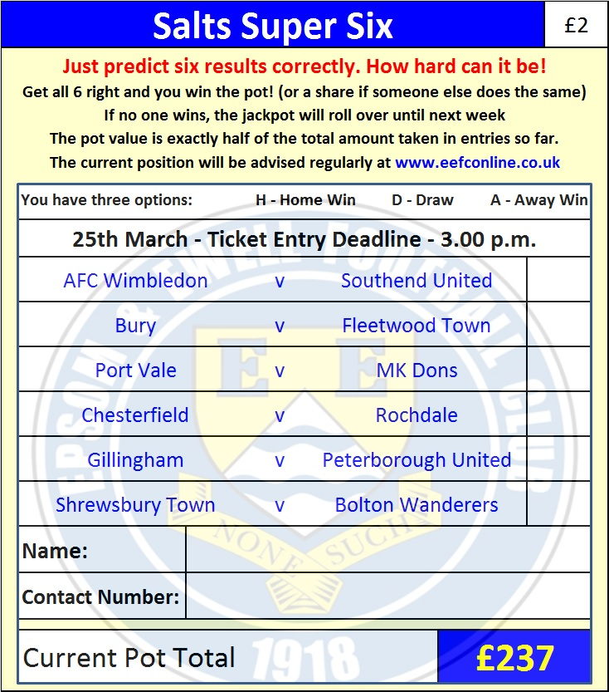

Good luck!

Combined Counties League – Premier Division
Saturday, 25th March 2017 - Kick-off 3.00 p.m.

Epsom and Ewell  (Royal Blue & White hoops) | V |  | Farnham Town  (Claret / Sky Blue)
Squad | NUMBERS |  | Squad
Michael Eacott |  |  | Richard Ossai
Adam Heagney |  |  | Adrian Giles
Matt Tanton |  |  | Max Meaton
James Taylor |  |  | Tom Smith
© Dan Dean |  |  | Doug Ford ©
Savvas ‘Agi’ Panayiotou |  |  | George Spiers
Jordan Gallagher |  |  | Ben Williams
Matt Farrell |  |  | Jack Dillion
Rob Hendry |  |  | Joe Clarke
Matt Ferdinando |  |  | Jack Cox
Reisse Griffin |  |  | Stan Staines
Jason Nwachukwu |  |  | Steve Ramsden
Craig Hastings |  |  | Darren Wilson
Daryl Cooper-Smith |  |  | Elliot Cardona
Alex McKay |  |  | Chris Poole
Ali Dewar |  |  | Dave Cooper
Alistair Turpie |  |  | Paul Coventry
Matt Smith |  |  | Nick Medcraft
Daniel Rose |  |  | Anthony Giles
Glyn Mandeville | MANAGER |  | Paul Tanner
Matt Smith | ASSISTANT
Steve Eacott / Alex McKay/  Jimmy Hendry | COACHES / PHYSIO |  | Alan Reed / Andy Sharratt / Emmanuel Boudine
REFEREE: H.Gilroy
ASSISTANTS: L.Torz-Brown, R.Redman
Today’s match and Match Ball are kindly sponsored
in memory of Jean Bexley

OUR NEXT VISITORS TO HIGH ROAD – please note earlier k.o. time
Colliers Wood United
Combined Counties League – Premier Division
Friday 14th April 2017 – 1.00 p.m.

